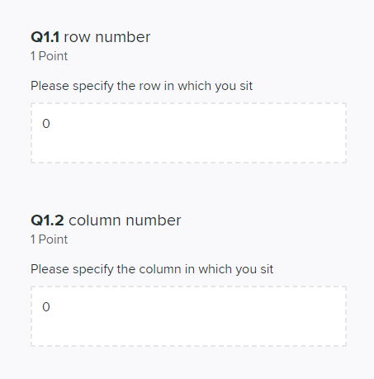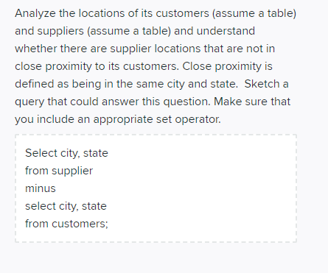 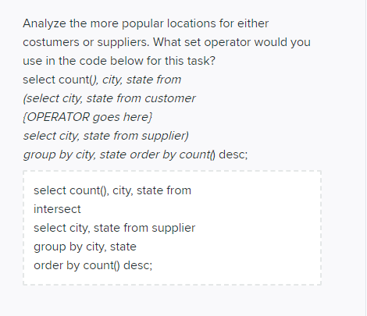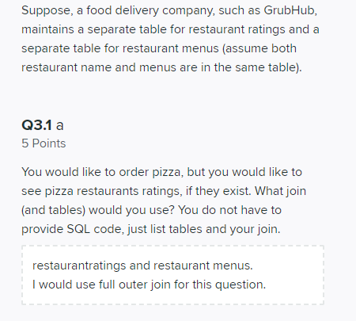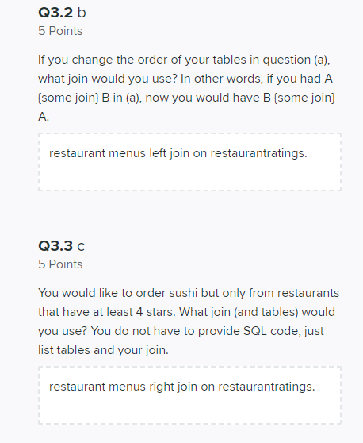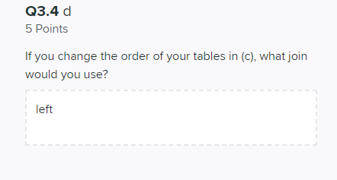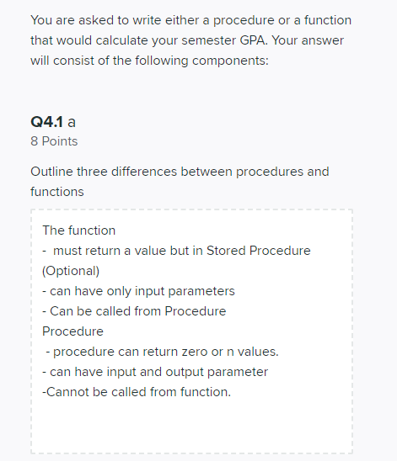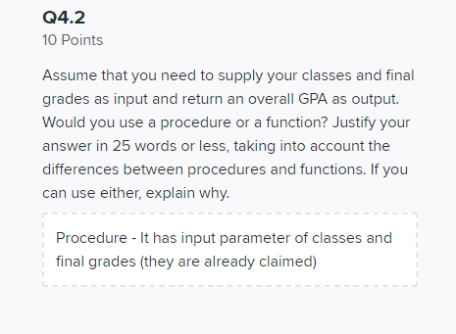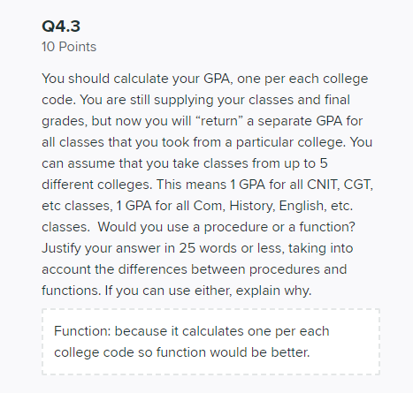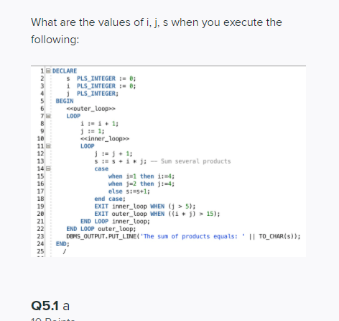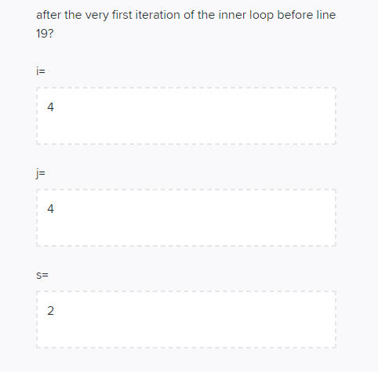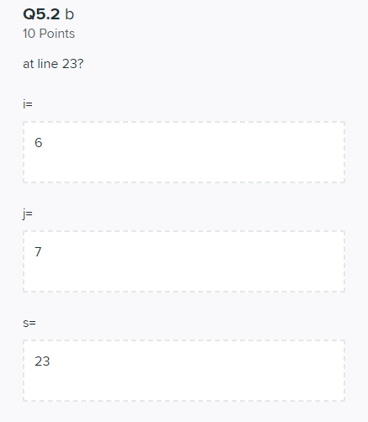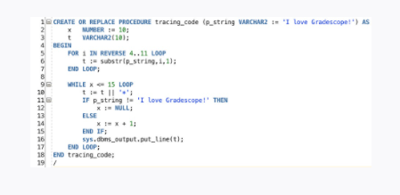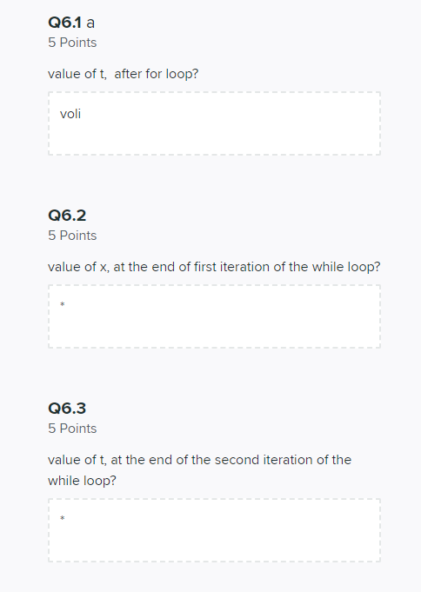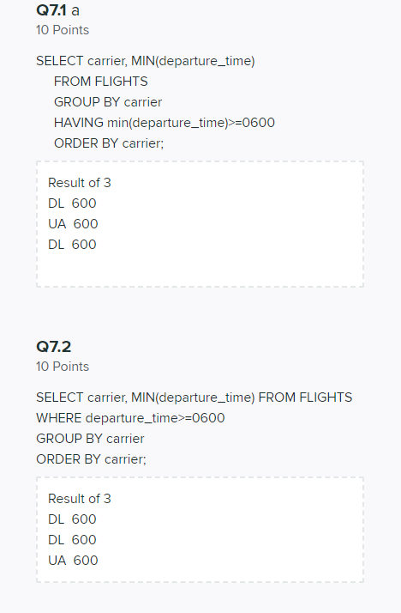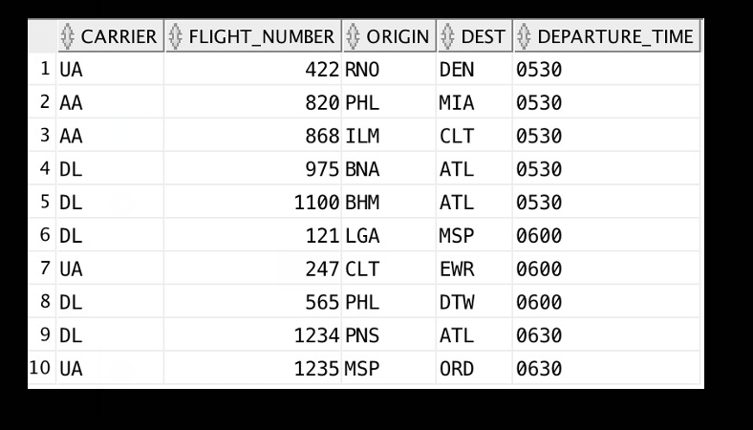

Select City, State

From Suppliers

MINUS

Select City, State

From Customers;

Select count(), city, state from

(select city, state from customer

INTERSECT

Select city, state from supplier

Group by city, state

Order by count() desc;

I would use tables:

PizzaOrder and PizzaRestaurants (contains rating)

Join:

Full outer join

PizzaOrder right join PizzaRestaurants

I would use a right join:

PizzaRestaurants right join PizzaOrder

I would use a left join

1. A function must have a return value but for stored procedures it is optional. Procedures can return zero or n values
2. Functions can only have input parameters, but procedures can have both input and output parameters
3. Functions can be called from procedures, but procedures cannot be called from functions.

Procedure. Because procedures can have input/output parameters

Function. Because you are returning a separate GPA for every colleges.

I=4

J=2

S=2

S=11

I=4

J=4

6.1

T=o

6.2

X = 10

6.3

T = o+

o++

o+++

o++++

o+++++

o++++++

Carrier min(departure_time)

----------------------------------------------

DL 0600

UA 0600

No rows selected